Forensic DNA Fingerprinting Kit
The Forensic DNA FIngerpinting Kit Manual is available here. It contains detailed instructions for background material, teacher prep, workstation prep and experimental procedures. We are providing this protocol as an additional guide to conducting this experiment in your classroom. Please see the manual, accompanying powerpoints and other listed resources for ideas on background material and alternative instructional timelines.
The kit is sufficient for 8 workstations of 2-4 students/station. We will provide the major equipment necessary for preparation and conducting the experiment. Other supplies (glassware, etc.) may be available upon request.

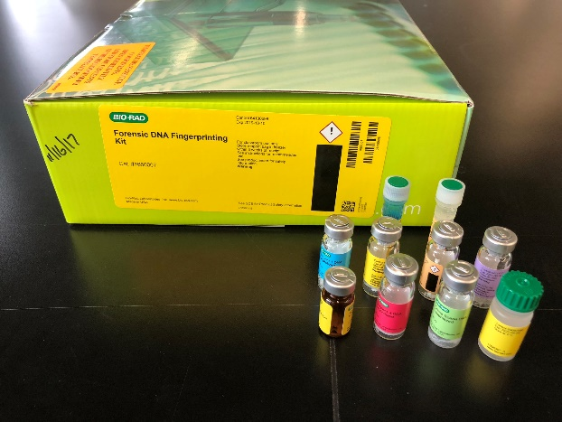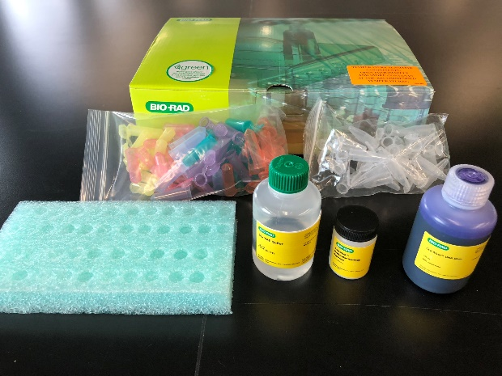

SUPPLIES

Kit Components Number/Kit

Crime Scene (CS) DNA with buffer, lyophilized, 60 µg 1 vial

Suspect 1 (S1) DNA with buffer, lyophilized, 60 µg 1 vial

Suspect 2 (S2) DNA with buffer, lyophilized, 60 µg 1 vial

Suspect 3 (S3) DNA with buffer, lyophilized, 60 µg 1 vial

Suspect 4 (S4) DNA with buffer, lyophilized, 60 µg 1 vial

Suspect 5 (S5) DNA with buffer, lyophilized, 60 µg 1 vial

EcoRI/PstI, restriction enzyme mix, lyophilized, 3,000 units 1 vial

Sterile water, 2.5 ml 1 vial

HindIII lambda digest (DNA size standard), 0.2 µg/µl, 100 µl 1 vial

DNA sample loading dye 1 vial

Fast Blast DNA stain, 500x, 100 ml 1 vial

Colored microcentrifuge tubes, 2.0 ml 60

Clear microcentrifuge tubes, 1.5 ml 30

Agarose powder, 5 g 1

Electrophoresis buffer, 50x TAE, 100 ml 1

Equipment and supplies provided
  - 1% precast agarose gels (backup if making your own)
  - Gel boxes with trays, combs, and power cables
  - Lab tape
  - Power supply
  - Micropipettors (2-20 ul)
  - Micropipettor (20-200 ul) (for teacher use)
  - Dry bath for 1.5 ml microcentrifuge tubes, with block
  - Microcentrifuge tube racks
  - Microcentrifuges
  - Micropipette tips
  - 1.5 ml microcentrifuge tubes (at least 30 tubes)
  - TAE running buffer (1X and 0.25X)
  - Plastic trays for staining/destaining

Optional supplies (we can provide if needed)
  - Flasks and graduated cylinders to make 1X and 0.25X TAE buffer
  - 125 ml Erlenmeyer flasks for melting agarose for gels
  - Bottles with screwcaps to store TAE buffer and Fast Blast Stain.

Equipment and supplies NOT included:
  - Hot plate with a magnetic stirrer or a microwave oven for dissolving agarose
  - 4 liters of distilled H2O for making 1X TAE running buffer (if buffer not provided)
  - Spatula to weigh agar
  - Weighing boats
  - Scale (0.4g)
  - Gloves
  - Waste containers
  - Sharpie markers
  - Crushed ice
  - Containers for ice
  - Millimeter ruler (post-lab activity)
  - Semi-log paper or access to a computer graphing program (post-lab activity)

TIMELINE (3-4 day lab; see p7 for same day lab)
This suggested timeline assumes the teacher is making the gels. We have pre-made gels or students can make them. The outline below incorporates students making the gels.
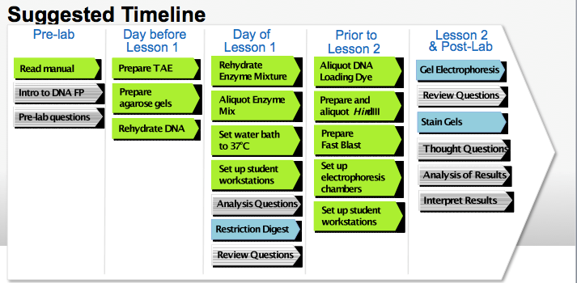
BEFORE LESSON

- Practice Pipetting: We recommend students practice pipetting with both transfer pipets and micropipets. See links to videos and written instructions below.
- Transfer pipette video
- Micropipet video
- Written micropipette instructions (Appx 1; Manual p16)

- Prepare Buffer – will be provided if needed
  - Prepare TAE Buffer from 50X TAE Buffer supplied – can be held at RT for one month. You will need 1X (for agarose gels) and 0.25X (electrophoresis) TAE Buffer. (Manual, p14) To make enough for 8 stations:
    - 1X TAE
3L = 60 ml 50X TAE + 2.94L distilled water
    - 0.25X TAE*
2.5L = 625 ml 1X TAE + 1875 ml distilled water

- Prepare 100X (same day) or 1X (overnight) FastBlast stain (Manual p17) – will be provided if needed
  - 100X: Dilute 100 ml of 500X Fast Blast with 400 ml of distilled or deionized water. Store at RT.
  - 1X: Dilute 1 ml of 500X Fast Blast with 499 ml of distilled or deionized water. Store at RT.

DAY 1 – Students prepare 1% agarose gels
Equipment and supplies needed
Gel boxes with trays, combs
Agarose powder
1X TAE buffer
Hot plate with a magnetic stirrer or a microwave oven for dissolving agarose
Spatula to weigh agar
Weighing boats
Scale (0.4g)
Lab tape
4 liters of distilled H2O for making 1X TAE running buffer (if buffer not provided)

- Casting Agarose gel
Casting an agarose gel video (Also see: Appendix 2; Powerpoint; Manual p14-15)
  - Use lab tape to seal the ends of the gel tray securely. Place 1 comb in the top of the tray.
  - In a 125ml flask, combine 0.4g agarose and 40 ml 1X TAE
  - Heat with a microwave or hot plate until solution boils and is completely clear. See detailed instructions, Appendix 2.
  - Once flask is comfortable to hold, pour agarose into tray.
  - Allow at least 10 minutes for gel to solidify. It will appear cloudy or opaque when ready to use. Carefully remove comb and tape.
  - Place tray into electrophoresis chamber with the sample wells at the black end of the base.
  - Gels can be stored at 4C for up to 1 week before using. Use a small sealable bag with 1-2ml 1X TAE buffer.

DAY 2 – Restriction Enzyme Digestion
Teacher Prep
A. Rehydrate DNA Samples (p13)
- Add 200 ul sterile water to each vial of DNA; use a new tip for each sample.
- Let stand at RT for a minimum of 15 minutes. May need to incubate at 37C for 10 minutes to help get DNA into solution.
- Store in refrigerator until use. May aliquot or have students come up to get it from a stock tube.

- Set up Student & Common Work Stations (Manual p11)
Student Workstation
EcoRI/PstI enzyme mix 1 tube (80 μl) – keep on ice until use
Pipet tips, 2–200 μl 15 tips
Adjustable micropipet, 2–20 μl
Colored microcentrifuge tubes: green, blue, orange, violet, pink, yellow
Microcentrifuge tube rack
Microcentrifuge
Permanent marker
Waste container
Foam micro test tube holder
Common Workstation
Crime scene (CS) DNA with buffer, rehydrated 1 vial
Suspect 1 (S1) DNA with buffer, rehydrated 1 vial
Suspect 2 (S2) DNA with buffer, rehydrated 1 vial
Suspect 3 (S3) DNA with buffer, rehydrated 1 vial
Suspect 4 (S4) DNA with buffer, rehydrated 1 vial
Suspect 5 (S5) DNA with buffer, rehydrated 1 vial
37°C water bath, dry bath, or incubator

- Set up water bath or dry bath at 37C – at least one hour prior to start.

- Rehydrate and aliquot enzyme mix **Do this the morning of the lab.
  - Add 750 µl sterile water to EcoRI/Pst; Rehydrate enzyme mix on ice for 5 min. Keep on ice until use. Must use within 12 hr of rehydrating.
  - Aliquot enzyme for student stations
    - Label 8 clear micro test tubes
    - Aliquot 80 µl of the enzyme
    - Keep on ice until used.

Student Procedure
- Restriction Digest – See Quick Guide (Manual p20)
  - Note: After the 45 min incubation, tubes can be stored in the refrigerator until the next class. If time allow, proceed to next Lesson.

DAY 3 – Electrophoresis
Teacher Prep (Manual p 17) – can be done before Day 2 or Day 3
- Prepare and aliquot Hindlll lambda digest (DNA standard)
  - Add 20 ul of DNA sample loading dye to Hindll lambda vial
  - Heat standard at 65C for 5 minutes, then place on ice
    - To allow small inner tube to contact heat in try bath: cut bottom of exterior tube or transfer to separate tube. **Be extremely careful if transferring. There is just enough standard + loading dye to aliquot required amount.
  - Label 8 clear micro test tubes “S”.
  - Aliquot 15ul DNA standard to each tube. Can be refrigerated until the next day.

- Aliquot DNA Loading Dye
  - Label 8 clear micro test tubes “LD”
  - Aliquot 50 ul of loading dye to each tube.
- Set up Student & Common Work Stations (Manual p12)

Student Workstation
Agarose gel electrophoresis system
Agarose gel (freshly made or precast)
Digested DNA samples (6)
HindIII lambda digest with loading dye (DNA standards) (1)
DNA sample loading dye (1)
Permanent marker
Pipet tips, 2–20 μl
Micropipet, 2–20 μl
Waste container
Large containers for destaining
Gel staining tray
Microcentrifuge tube rack
Foam micro test tube holder

Common Workstation
Power supply for electrophoresis units
Electrophoresis buffer (1x TAE)
Fast Blast DNA stain, 1x or 100x

Student Procedure
- Electrophoresis – See Quick Guide (Powerpoint; Manual p21)
  - Note: Step 7 – load entire volume of standard
  - Use 0.25X TAE buffer*
  - Run gel at 200V for 20 minutes
- Visualization of DNA Fragments – See Quick Guide (Manual p36-38)
  - Quick stain: Use 100X Fast Blast stain
  - Overnight staining: Use 1x Fast Blast stain

* The manual and powerpoint use 1X TAE to run the gels. By using 0.25X TAE, the gels can be run in 20 minutes.

If doing the lab in one day:
Make the day before:
- Prepare buffers (1X and 0.25X TAE)
- Rehydrate DNA Samples
- Prepare and aliquot Hindlll lambda digest (DNA standard)
- Aliquot DNA Loading Dye
- Prepare Fast Blast: 50x for quick stain; 1x for overnight

Morning of class:
- Rehydrate and aliquot enzyme mix

~~~~~~~~~~~~~~~~~~~~~~~~~~~~~~~~~~~~~~~~~~~~~~~~~~~~~~~~~~~~~~~~~~~~~~~~~~~~~~
POST-LAB ACTIVITY Analysis and Interpretation of Results (Manual p42)

EXTENSION ACTIVIY 1 Plasmid Mapping (Manual p47)

EXTENSION ACTIVITY 2 Constructing a Plasmid (Manual p55)

Appendix 1: Practice Using Micropipets
We recommend that you familiarize your students with proper pipeting techniques prior to Lesson 1. Have your students learn how to transfer different volumes of a solution from one tube into another with a micropipet. Students may practice by using either sample loading dye or food coloring mixed with either a dense saturated sugar or glycerol solution. Here is a quick summary on how to use micropipets:
1. Look at the micropipet to determine the volume range.
2. Twist the dial on the micropipet to set the desired volume.
3. Attach a clean pipet tip.
4. Press the micropipet plunger to the first (soft) stop.
5. Insert the pipet tip into the solution to be transferred.
6. Slowly release the plunger to retrieve the liquid.
7. Insert the pipet tip into the desired tube.
8. Press the plunger past the first stop to the second (hard) stop to transfer the liquid. Make sure to keep the plunger pressed when lifting the pipet tip out of the tube.
9. Eject the pipet tip.

Appendix 2: Gel Electrophoresis Protocol
MATERIALS:
- Fresh 1X TAE Buffer (CAT #166-0742)
- BIO-RAD Certified™ Molecular Biology Agarose (CAT #161-3100)
BASIC INFORMATION:
- Biotechnology Explorer™ Forensic DNA Fingerprinting Kit: 1% Gel (0.4g Agarose, 40 mL 1X TAE)
- Biotechnology Explorer™ GMO Investigator™ Kit: Use pre-made Gels or 3% Gel (1.2g Agarose, 40 mL 1X TAE)
GEL MAKING:
- Measure out 40 mL of 1X TAE - Use Fresh Diluted TAE
- Weigh out Agarose - Amount per Kit listed above
- Mix well and melt completely by Microwave or Hot Plate - Melt until Clear
HOT PLATE |  | MICROWAVE
1. Place a rubber stopper or folded paper towel in 125 ml Erlenmeyer flask |  | 1. Place a rubber stopper or folded paper towel in 125 mL Erlenmeyer flask
2. Turn Hot Plate on to 95 degrees Celsius or to medium/high temperature |  | 2. Microwave for about 20-30 seconds – If it bubbles stop it immediately
(It melts into solution at 85-95˚C) |  | 3. Take out and swirl
3. Heat until it is clear swirling every few minutes |  | 4. Microwave for about 7 seconds – If it bubbles stop it immediately
(If it bubbles pull it off immediately but be careful it will be hot) |  | 5. Take out and swirl (Careful it will be warm)
7. Once it is clear take off and swirl (Careful it will be hot) |  | 6. Microwave for about 4 seconds – If it bubbles stop it immediately
8. Let it cool on your bench for 5-10 minutes before pouring gel or until you can hold it |  | 7. Take out and swirl (Careful it will be hot)
 |  | 8. Let it cool on your bench for 5-10 minutes before pouring gel or until you can hold it
WATCH CAREFULLY! IT SHOULD NOT BOIL
- While your gel is cooling assemble gel casting apparatus (Tape only to the cassette not tape-on-tape)
- Pour into Gel Apparatus and add comb.
- Let cool until it has solidified and turned opaque (~10-15 minutes).
- Remove comb from gel by pulling straight up.
- Gel can be stored in its tray, in the refrigerator, sealed in a zip lock bag with 1-2ml 0.25X TAE buffer for up to one week

GEL RUNNING:
- Place gel into running chamber, make sure TAE buffer covers the top of the gel
- Load Samples. Run at 200V for 20 minutes

